Assignment 13.1
Scala application to find the GCD of two numbers.


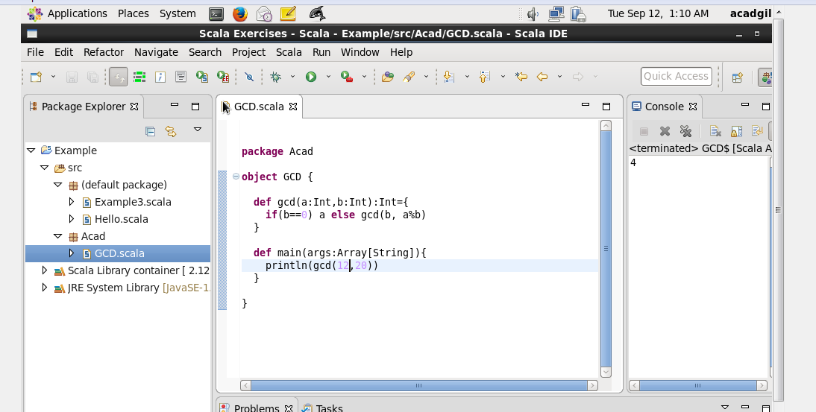

package Acad

object GCD
{
def gcd(a:Int,b:Int):Int={
if(b==0) a else gcd(b, a%b)
}
def main(args:Array[String])
{
Println (gcd(12,20))
}
}

